**Database migration using managed Database Migration Service**

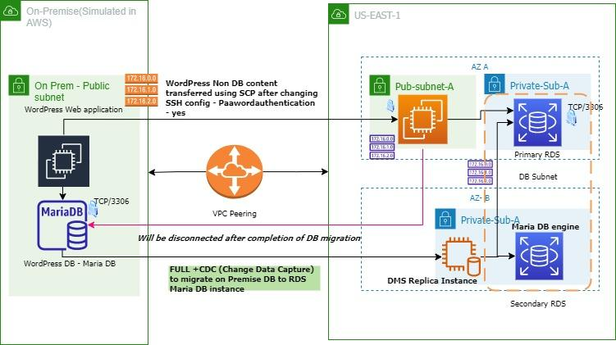

1. Created On-Premise infrastructure (simulated in AWS) - The on-premises environment is a virtual web server (simulated using EC2) and a self-managed mariaDB database server (also simulated via EC2)

1.1 setup EC2 instance to host word press application (AMI - **am**i-0bf6ba120443f8e1f exclusive for wordpress application) , customised userdata to update DB parameters (from Parameter store)

#!/bin/bash -xe

# Configure Wordpress

cd /var/www/html

cp ./wp-config-sample.php ./wp-config.php

sed -i "s/'localhost'/'${onpremCatDB.PrivateIp}'/g" wp-config.php

sed -i "s/'database_name_here'/'${DBName}'/g" wp-config.php

sed -i "s/'username_here'/'${DBUser}'/g" wp-config.php

sed -i "s/'password_here'/'${DBPassword}'/g" wp-config.php

/home/ec2-user/update_wp_ip.sh

/opt/aws/bin/cfn-signal -e $? --stack ${AWS::StackId} --resource onpremCatWeb --region ${AWS::Region}

2. Created on premise DB (Maria DB) using AMI - ami-0319a571f9ff661d7

3. Created AWS end infrastructure , having **1 public subnet and 2 private subnets across two availability zones. 1 security group configured to accept internet traffic at TCP/80 port for web application and 1 security group for RDS configured to accept traffic at tcp/3306 port**

4. Created RDS Database subnet in private subnets across two availability zones. Created RDS Database instance , Maria DB engine in high availability mode with primary DB in one zone and standby DB in another zone.

5. Move WordPress non DB content to AWS end EC2 server with SSH config - Passwordauthentication yes and transferred using SCP.

run a nano /etc/ssh/sshd_config

locate PasswordAuthentication no and change to PasswordAuthentication yes ,

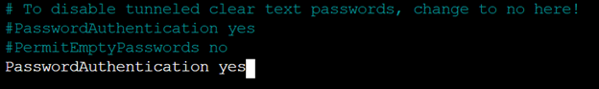

then set a password on the ec2-user user

run a passwd ec2-user and enter the password





6. Created **DMS Replica Instance in private subnet at AWS end with Single AZ mode**

6.1 Created source endpoint as shown below,

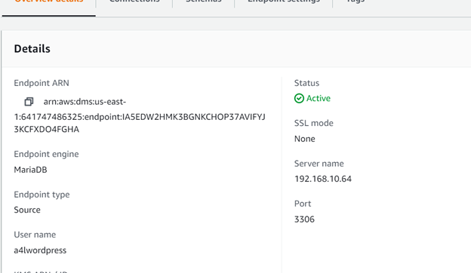

6.2 created target endpoint as shown below

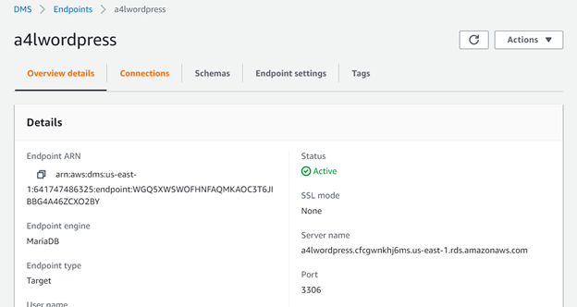

6.3 created database migration task with source endpoint, target endpoint , replication instance and migration type as shown below

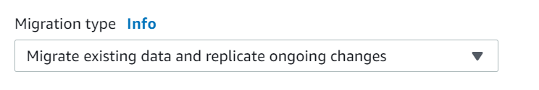

Once on premise mariaDB data is migrated into AWS RDS maria db instance , change DB host parameter (wp-config.php) to point to RDS DB endpoint



Now, as part of cutover of the application instance, on premise web application and DB servers are stopped, word press application is working as expected.